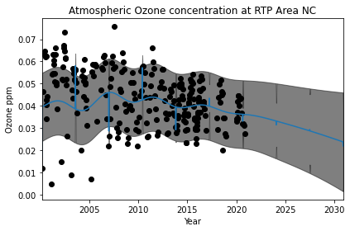

GPML kernel: 66**2 * RBF(length_scale=67) + 2.4**2 * RBF(length_scale=90) * ExpSineSquared(length_scale=1.3, periodicity=1) + 0.66**2 * RationalQuadratic(alpha=0.78, length_scale=1.2) + 0.18**2 * RBF(length_scale=0.134) + WhiteKernel(noise_level=0.0361)

Log-marginal-likelihood: -475.750

Learned kernel: 30.9**2 * RBF(length_scale=57.8) + 1.14**2 * RBF(length_scale=5.2e+03) * ExpSineSquared(length_scale=0.000162, periodicity=0.286) + 0.326**2 * RationalQuadratic(alpha=17.7, length_scale=1.89) + 0.0108**2 * RBF(length_scale=0.483) + WhiteKernel(noise_level=0.169)

Log-marginal-likelihood: -238.426

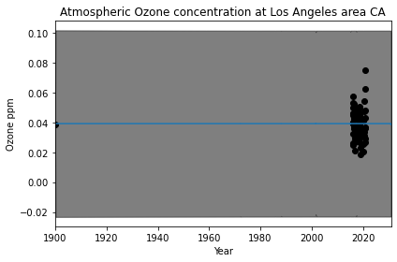

GPML kernel: 66**2 * RBF(length_scale=67) + 2.4**2 * RBF(length_scale=90) * ExpSineSquared(length_scale=1.3, periodicity=1) + 0.66**2 * RationalQuadratic(alpha=0.78, length_scale=1.2) + 0.18**2 * RBF(length_scale=0.134) + WhiteKernel(noise_level=0.0361)

Log-marginal-likelihood: -577.215

C:\Users\eveba\.conda\envs\Machine_Learning\lib\site-packages\sklearn\gaussian_process\kernels.py:402: ConvergenceWarning: The optimal value found for dimension 0 of parameter k2__k1__k2__length_scale is close to the specified lower bound 1e-05. Decreasing the bound and calling fit again may find a better value.

warnings.warn("The optimal value found for "

Learned kernel: 3.9**2 * RBF(length_scale=795) + 2.17**2 * RBF(length_scale=24.4) * ExpSineSquared(length_scale=0.00298, periodicity=1.26e-05) + 0.542**2 * RationalQuadratic(alpha=16.2, length_scale=0.003) + 6.19**2 * RBF(length_scale=1e-05) + WhiteKernel(noise_level=0.28)

Log-marginal-likelihood: -191.324

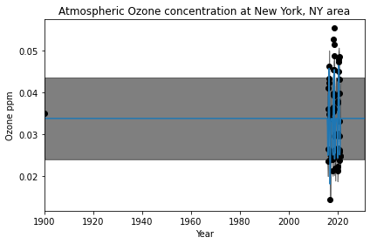

GPML kernel: 66**2 * RBF(length_scale=67) + 2.4**2 * RBF(length_scale=90) * ExpSineSquared(length_scale=1.3, periodicity=1) + 0.66**2 * RationalQuadratic(alpha=0.78, length_scale=1.2) + 0.18**2 * RBF(length_scale=0.134) + WhiteKernel(noise_level=0.0361)

Log-marginal-likelihood: -88.644

Learned kernel: 0.00316**2 * RBF(length_scale=2.49e+03) + 0.936**2 * RBF(length_scale=182) * ExpSineSquared(length_scale=0.000161, periodicity=3.83e+03) + 0.00316**2 * RationalQuadratic(alpha=16.7, length_scale=19.7) + 0.00316**2 * RBF(length_scale=0.00146) + WhiteKernel(noise_level=0.115)

Log-marginal-likelihood: -53.650

C:\Users\eveba\.conda\envs\Machine_Learning\lib\site-packages\sklearn\gaussian_process\kernels.py:402: ConvergenceWarning: The optimal value found for dimension 0 of parameter k1__k1__k1__k1__constant_value is close to the specified lower bound 1e-05. Decreasing the bound and calling fit again may find a better value.

warnings.warn("The optimal value found for "

C:\Users\eveba\.conda\envs\Machine_Learning\lib\site-packages\sklearn\gaussian_process\kernels.py:402: ConvergenceWarning: The optimal value found for dimension 0 of parameter k1__k2__k1__constant_value is close to the specified lower bound 1e-05. Decreasing the bound and calling fit again may find a better value.

warnings.warn("The optimal value found for "

C:\Users\eveba\.conda\envs\Machine_Learning\lib\site-packages\sklearn\gaussian_process\kernels.py:402: ConvergenceWarning: The optimal value found for dimension 0 of parameter k2__k1__k1__constant_value is close to the specified lower bound 1e-05. Decreasing the bound and calling fit again may find a better value.

warning.warn("The optimal value found for "

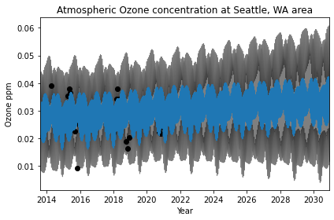

GPML kernel: 66**2 * RBF(length_scale=67) + 2.4**2 * RBF(length_scale=90) * ExpSineSquared(length_scale=1.3, periodicity=1) + 0.66**2 * RationalQuadratic(alpha=0.78, length_scale=1.2) + 0.18**2 * RBF(length_scale=0.134) + WhiteKernel(noise_level=0.0361)

Log-marginal-likelihood: -72.026

Learned kernel: 25**2 * RBF(length_scale=86) + 2.93**2 * RBF(length_scale=172) * ExpSineSquared(length_scale=0.287, periodicity=0.000813) + 0.342**2 * RationalQuadratic(alpha=17.5, length_scale=1.72) + 0.393**2 * RBF(length_scale=0.00101) + WhiteKernel(noise_level=1.13)

Log-marginal-likelihood: -61.013

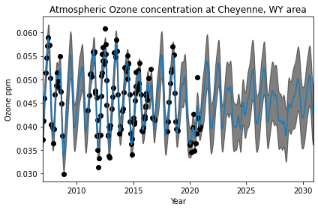

GPML kernel: 66**2 * RBF(length_scale=67) + 2.4**2 * RBF(length_scale=90) * ExpSineSquared(length_scale=1.3, periodicity=1) + 0.66**2 * RationalQuadratic(alpha=0.78, length_scale=1.2) + 0.18**2 * RBF(length_scale=0.134) + WhiteKernel(noise_level=0.0361)

Log-marginal-likelihood: -179.191

Learned kernel: 0.00316**2 * RBF(length_scale=3.78e+03) + 0.901**2 * RBF(length_scale=12.6) * ExpSineSquared(length_scale=0.252, periodicity=4.03) + 0.0546**2 * RationalQuadratic(alpha=24.4, length_scale=0.146) + 0.389**2 * RBF(length_scale=0.218) + WhiteKernel(noise_level=0.121)

Log-marginal-likelihood: -114.467

C:\Users\eveba\.conda\envs\Machine_Learning\lib\site-packages\sklearn\gaussian_process\kernels.py:402: ConvergenceWarning: The optimal value found for dimension 0 of parameter k1__k1__k1__k1__constant_value is close to the specified lower bound 1e-05. Decreasing the bound and calling fit again may find a better value.

warnings.warn("The optimal value found for "